**GUVI Database in MONGODB**

GUVI DATABASE:

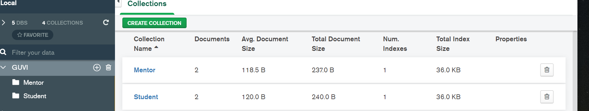

Mentor Collection with Documents:

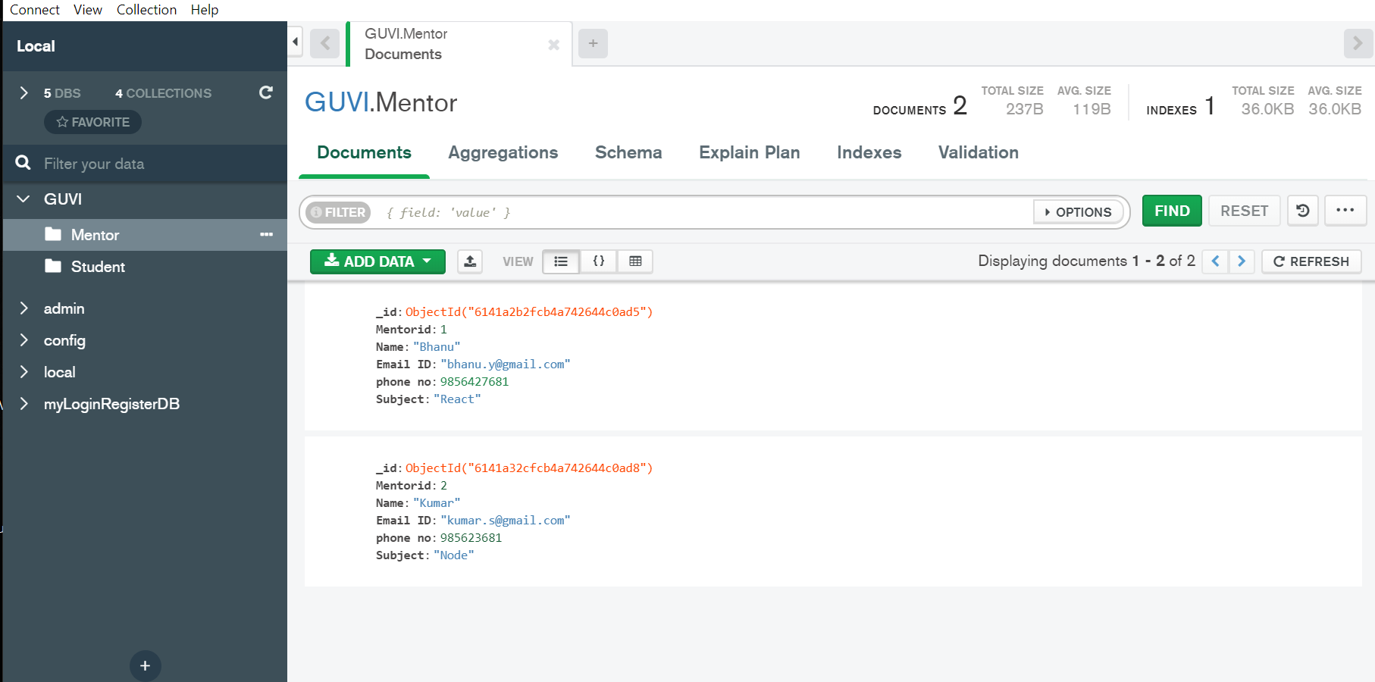

Student Documents with collection:

